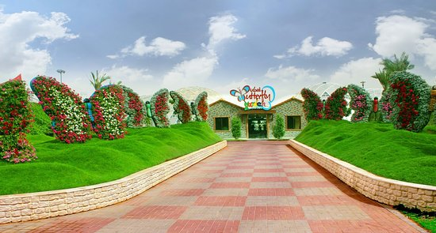https://www.google.co.nz/url?sa=i&source=images&cd=&cad=rja&uact=8&ved=2ahUKEwiHs8DcnevcAhUWM94KHQLVADsQjRx6BAgBEAU&url=https%3A%2F%2Fwww.tripadvisor.com%2FAttraction_Review-g295424-d8467864-Reviews-Dubai_Butterfly_Garden-Dubai_Emirate_of_Dubai.html&psig=AOvVaw35luBkaGg9rylqwOMs82Gv&ust=1534290941200353

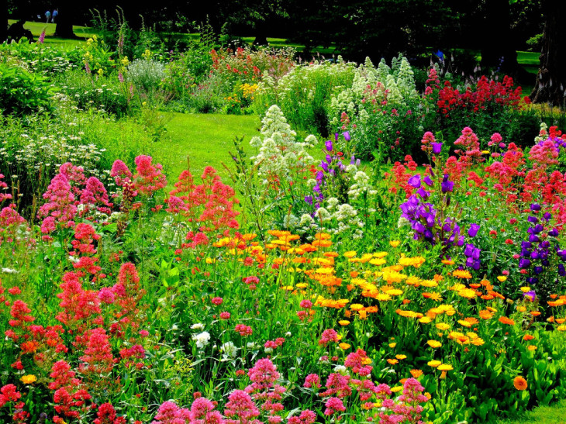https://techcrunch.com/2018/04/10/a-new-app-called-garden-helps-you-stay-in-touch-with-friends-and-family-without-facebook/

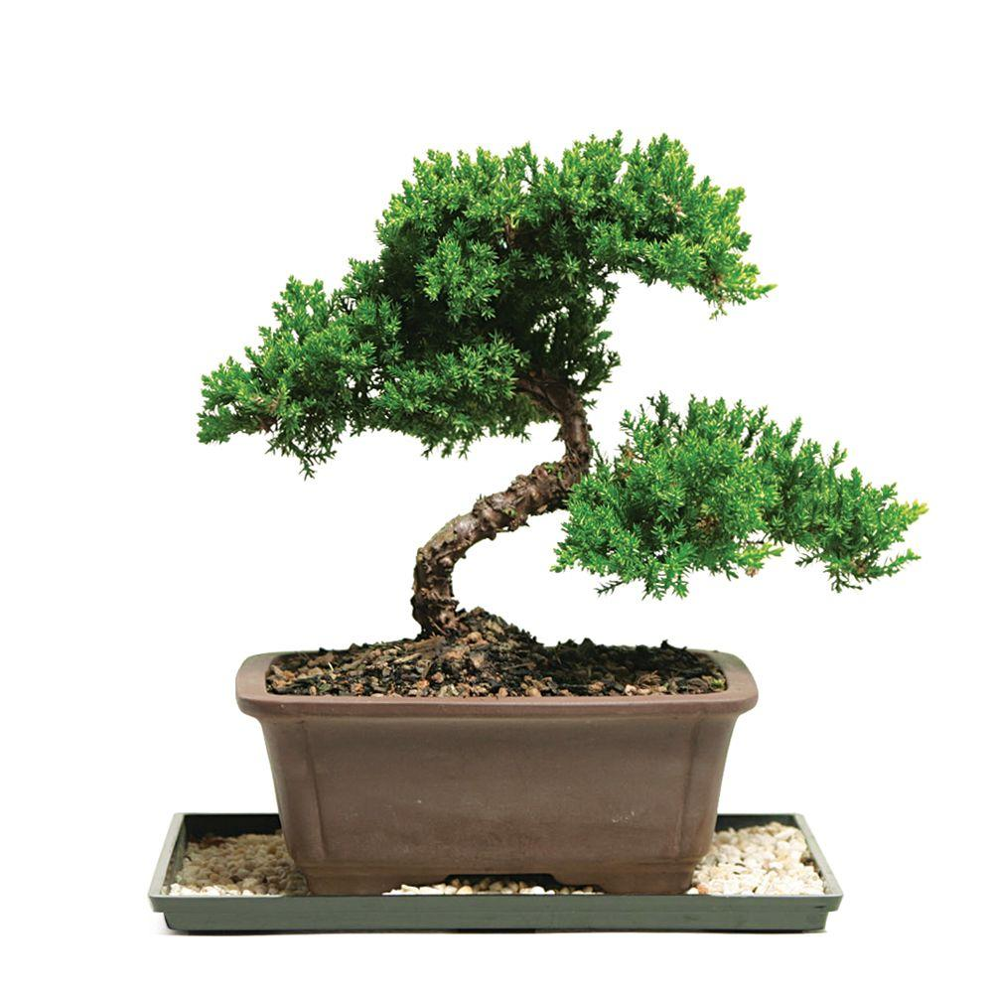https://www.homedepot.com/p/Brussel-s-Bonsai-Green-Mound-Juniper-Bonsai-Outdoor-DT-7079GMJ/100651255

https://www.davidharber.co.uk/sculpture.htm

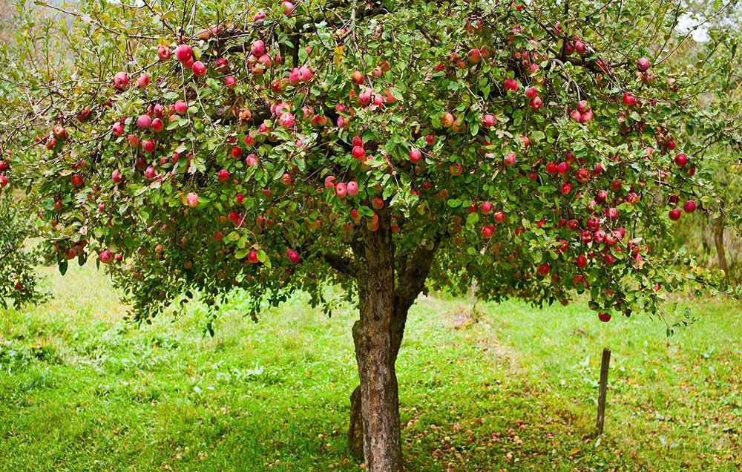

https://www.123rf.com/photo_7999347_apple-trees-in-an-orchard-with-red-apples-ready-for-harvest.html

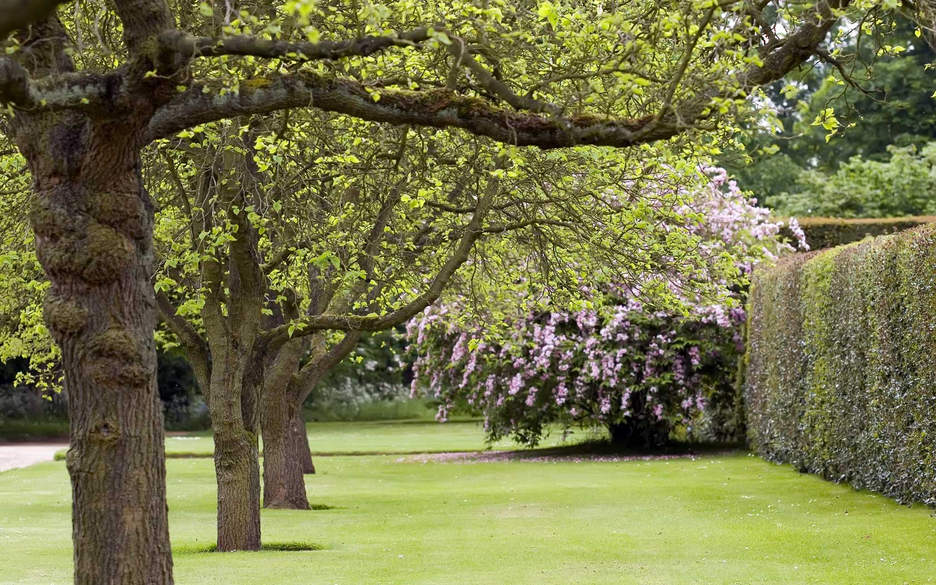http://homecaprice.com/exteriordesign/garden-trees-for-hot-climate/